**BMS18 2018-2019**

**Computer Session: Conducting a meta-analysis**

**Solutions**

*Background:*

Before the statistical meta-analysis can be done, the important figures have to be extracted from the selected articles. After entering these figures in an appropriate software tool, the meta-analysis results become easily available.

*Objectives:*

Upon completion of this assignment the student will be able to:

* Perform meta-analysis using
  + Excel (i.e. DIY: do the calculations yourself),
  + Review Manager (from the Cochrane Collaboration),
  + the software package R.
* You will apply different approaches (fixed-effect and random-effects), and different weights (Mantel-Haenszel and Inverse-Variance weights).

*Instruction:*

You can work alone or in couples.

*Product:*

The output, data files and written answers to the questions.

We will discuss the output during the **Working Group** after this computer assignment.

**The data: neonatal mortality in preterm breech.**

There is controversy on the preferred mode of delivery (vaginal delivery (VD) versus caesarean section (CS)) in preterm breech delivery in relation to neonatal outcome. While CS is supposed to be safer for the fetus, arguments against CS can be the increased risk of maternal morbidity, risks for future pregnancies, and costs. Moreover, neonatal respiratory distress syndrome occurs more frequently after CS compared to VD.

In the past, several RCTs have been started on this subject, but they were all preliminary and stopped due to recruitment difficulties. As the Cochrane review of these RCT’s reported on 116 women only, knowledge on the effectiveness of CS and VD can at present only be obtained from non-randomized studies.

We performed a systematic review and meta-analysis of non-randomized studies that assessed the association between mode of delivery and neonatal mortality in women with preterm breech presentation. We searched Pubmed, Embase and the Cochrane library for articles comparing neonatal mortality after VD versus CS in preterm breech presentation (gestational age 25+0 till 36+6 weeks). Seven studies, involving a total of 3557 women, met the eligibility criteria and were included in this systematic review.

The neonatal_mortality.xlsx file contains results from 7 randomized clinical trials, designed to investigate the effect of breech on perinatal death.

The file looks as follows:

|  |  |  |  |  |  |
| --- | --- | --- | --- | --- | --- |
| **Author** | **year** | **CS_events** | **CS_total** | **VD_events** | **VD_total** |
| Van Eijk 1983 | 1983 | 3 | 33 | 8 | 50 |
| Malhotra 1994 | 1994 | 17 | 96 | 44 | 128 |
| Ziadeh 1997 | 1997 | 4 | 32 | 9 | 66 |
| Wolf 1999 | 1999 | 10 | 46 | 17 | 101 |
| Warke 1999 | 1999 | 9 | 50 | 32 | 112 |
| Herbst 2006 | 2006 | 38 | 1975 | 27 | 699 |
| Kayem 2008 | 2008 | 6 | 85 | 9 | 84 |

CS_events is the number of events (perinatal deaths) after CS, CS_total is the total number of CS deliveries.

VD_events is the number of events after VD, VD_total is the total number of VD deliveries.

*From*: Bergenhenegouwen LA, Meertens LJ, Schaaf J, Nijhuis JG, Mol BW, Kok M, Scheepers HC. Vaginal delivery versus caesarean section in preterm breech delivery: a systematic review. European Journal of Obstetrics & Gynecology and Reproductive Biology. 2014 Jan 1;172:1-6.

During this exercise we will gradually fill the following tables.

**Table 1 RR and 95% Confidence Interval per approach (3 decimals)**

|  |  |  |  |  |
| --- | --- | --- | --- | --- |
|  |  | **Excel (manually)** | **RevMan** | **R** |
| **Naive pooled RR 1** (based on sums) |  | 0.319 |  |  |
| **Naive pooled RR 2** (based on average risks per mode) |  | 0.710 |  |  |
| **Fixed Effect (FE)** | Inverse Variance weights (IV) | 0.627  (0.485; 0.811) |  |  |
|  | Mantel Haenszel weights (MH) |  |  |  |
|  |  |  |  |  |
| **Ramdom Effects (RE)** | Inverse Variance weights (IV) |  |  |  |
|  | Mantel Haenszel weights (MH) |  |  |  |

**Table 2 Study weights (as %) per approach**

|  |  |  |  |  |  |
| --- | --- | --- | --- | --- | --- |
|  | **Excel (Naive)** | **FE, IV** | **FE, MH** | **RE, IV** | **RE, MH** |
| Van Eijk 1983 | based on study size | 4.2 |  |  |  |
| Malhotra 1994 |  | 27.1 |  |  |  |
| Ziadeh 1997 |  | 5.4 |  |  |  |
| Wolf 1999 |  | 13.5 |  |  |  |
| Warke 1999 |  | 15.1 |  |  |  |
| Herbst 2006 |  | 27.9 |  |  |  |
| Kayem 2008 |  | 6.7 |  |  |  |

**Meta-analysis with Excel**

1. Use Excel to calculate the pooled risk of perinatal death in each delivery mode group.
   1. You can start a formula in Excel with the “=” sign, and referring to (by clicking on) the appropriate cells that must be included in the formula. We start by calculating the sum of the events in the CS_events column.
   2. You can copy the formula to the other columns by clicking on the cell with the formula in the lower right corner, and dragging the formula to the right to the other columns.
   3. Create formulas to calculate the pooled risk for each delivery mode
   4. Use these to calculate the pooled risk ratio (RR) for CS vs VD.

Naive pooled RR is 0.319

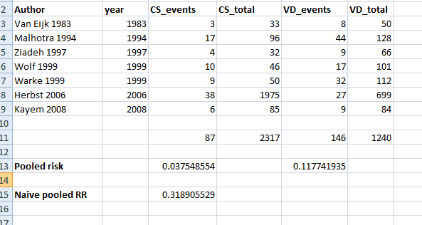

1. Use Excel to calculate the risk per delivery mode per study (i.e. CS risk and VD risk per study), in columns to the right of the study data, and calculate the average risk per delivery mode, and the Risk Ratio based on these risks.

|  |  |  |
| --- | --- | --- |
| CS risk 0.1257 | VD risk 0.1771 | **Naive RR** 0.7099 |
|  |  |  |

1. Use Excel to calculate the risk ratio (RR). The risk ratio is calculated as the division of the Risk of Death in the CS and the VD group.

In a 2x2 matrix

|  |  |  |  |
| --- | --- | --- | --- |
|  | **Outcome** | | **Total** |
| **Treatment** | **Event** | **No event** |  |
| Caesarean Section | a | b | a+b |
| Vaginal Delivery | c | d | c+d |
| **Total** | a+c | b+d | a+b+c+d |

The RR is calculated as $\frac{\frac{a}{a+b}}{\frac{c}{c+d}}$, or you can calculate the RR as CS_risk/VD_risk.

1. We will conduct manually a fixed effect meta-analysis, using Excel.   
   As the RR itself is not normally distributed, we will conduct this meta-analysis on Ln(RR).   
   Calculate the Ln(RR) (by using the =Ln function) for each study.

Calculate the variance of the Ln(RR). You need the variances per study to define the “inverse variance” weights of the studies.

Var of Ln(RR) = $\frac{1}{a}$- $\frac{1}{a+b}$ + $\frac{1}{c}$- $\frac{1}{c+d}$

(if you want to calculate confidence intervals per study: SE of the Ln(RR) = $\sqrt{Var}$)

1. Do manually a fixed effect analysis using Excel and the calculated Ln(RR)’s and Var’s
   1. Calculate the weights (Inverse Variance) of the studies as 1/ Var (IV*weights*)
   2. Multiply each study result (LN(RR) by the corresponding weight, to create *weightedES* (weighted effect size).
   3. Sum the weights in (a). *(SumWeights)*
   4. Sum the results of (b). *(SumES)*
   5. The fixed effect estimate for the pooled LN(RR) is equal to: *SumES/ SumWeights.*
   6. Back-transform the result into the RR by exponentiating (=EXP()) it.
2. Calculate the 95% CI Confidence Interval for the pooled RR as follows:  
   By definition, the variance of the pooled estimate of LN(RR) is equal to 1/SumWeights, therefore the standard error (SE) of the LN_RR is equal to the square root of this number.   
   1. Use this to calculate the 95% confidence interval for the pooled LN_RR.
   2. Back-transform the 95% CI to the RR scale by exponentiating. Note that the resulting confidence interval for the RR will be asymmetric!
   3. Write the results in the first table above.
3. Usually, the study weights are presented percentages, summing in total to 100%.   
   Therefore we will calculate the study weights as a percentage (*%weight*).
   1. Calculate for the first study the %weight as 100* *IVweight/Sumweights*.   
      If your cursor is on the Sumweights cell, press F4, with the effect that the cell will be referred to with $ signs, eg. $P$11. This creates an absolute reference in the formula (instead of a relative one), such that this specific cell will be used, even when you copy the formula to other places.
   2. Copy the formula for the other studies.
   3. Check that the sum of the %weights is now equal to 100.
   4. Write the results in the second table above.

Solution

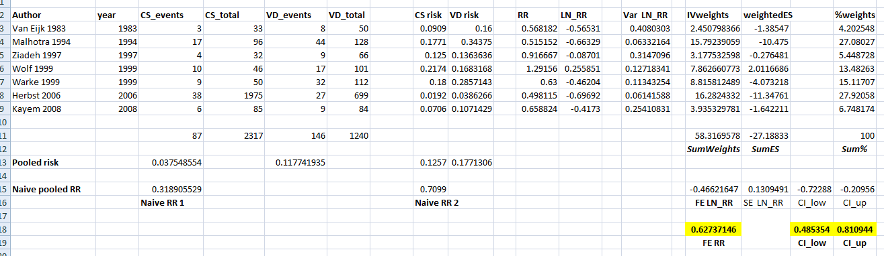

**Meta-analysis with Review Manager**

1. First, Open RevMan by double clicking on the Review Manager icon.

[Related image](https://macdownload.informer.com/review-manager/5.3/)

1. Review Manager (RevMan) is The Cochrane Collaboration’s software for preparing and maintaining Cochrane reviews. RevMan facilitates preparation of protocols and full reviews, including text, characteristics of studies, comparison tables, and study data.

In addition to reviews of studies of the effects of healthcare interventions, you can use RevMan to write reviews of diagnostic test accuracy studies, reviews of studies of methodology and overviews of reviews.

If you use RevMan, always cite it whenever its output is used in works other than Cochrane Reviews.

1. The reason why we use it today is that it can perform meta-analysis of the data entered, and present the results graphically, and is freely available, even if you are not performing a Cochrane review.
2. You will see the welcome screen.
3. Press “View Help”. RevMan5help is always available by clicking **F1**. The F1 help file focuses primarily on Cochrane Intervention reviews, with special sections for the features that are specific to the other review types.
4. Press “Handbook”. The Cochrane handbook is freely available online, but also approachable within RevMan, by pressing **F2**.
5. Close the welcome screen.

## Creating a new review

## We will create a review for the neonatal mortality for preterms in breech (CS vs. VD) data.

1. **Step 1:**Click the New button on the toolbar. This opens the New Review Wizard, and you can create a title for your review. Follow the steps in the wizard
   1. Indicate which type of review you want to make. >next.
   2. Create a suitable title. >next.
   3. Choose “full review”, as we will use RevMan to conduct a meta-analysis. >finish.
2. Revman is a program created for Cochrane reviews. We will just use it to conduct a meta-analysis, therefore many options can be ignored. To manoeuvre through RevMan, the left pane in RevMan is very important. Look at all the options in the left pane.



1. **Step 2:**The next step is to make our **studies** available in RevMan.   
   In the left pane, double-click on “Included studies”, to include our 7 studies (one by one). You can either work in the left pane, by pressing your right mouse-click, and select “Add Study”, or in the right pane, by pressing the button “Add Study”.
2. Add the 7 studies. Presence of an identifier per study is sufficient, like “Van Eijk 1983”. No other information or literature references are needed for our purpose.   
   If you are ready, check that all studies are present under “Included studies”.
3. **Step 3:**The next step, before you can conduct a meta-analysis, is to add the **comparison** that you are interested in, i.e. the treatments/interventions that you want to compare.   
   Which is the comparison that you are interested in?

The comparison between CS and vaginal delivery mode.

1. You can add this comparison by right-clicking in the left pane on “Data and analyses”, press “Add Comparison” and give the comparison a suitable name (related to the intervention).

Eg: Delivery mode, or Caesarean Section vs. Vaginal Delivery mode

1. **Step 4:**The next step is to add the **outcome** that you are interested in. Each outcome will correspond to a meta-analysis.   
   Press “Add an outcome to the comparison”. > continue.
2. In which outcome are we interested in this review?   
   Do you think this is a binary (dichotomous) outcome or a continuous outcome (per patient / baby), or one of the other options?

We are interested in how many babies died, i.e. perinatal mortality.  
We know how many deliveries there were with perinatal mortality and how many without mortality. On preterm level, this means that a newborn baby did or did not die, which makes it a binary outcome.

1. Fill in an appropriate name for the outcome and for the group labels (of both delivery modes). >next.
2. The screenshot below shows options that are related to the statistical analysis. Below you see the default setting. These options can easily be changed during the meta-analysis. Therefore you may stick to the default settings as a start.   
   Note that the default setting for the analysis model is a Fixed Effect model.   
   > Finish.

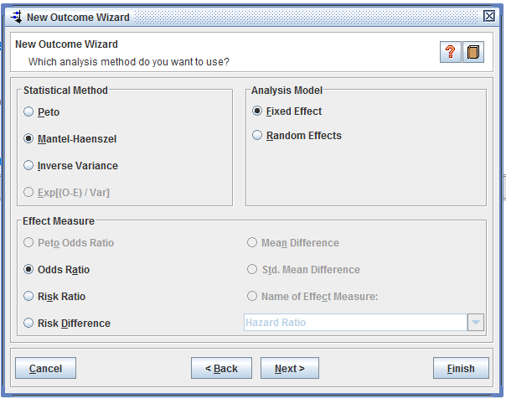

1. **Step 5:**   
   You will see a data table for a meta-analysis, but there are no data in it. In order to add **studies** to your meta-analysis, there are two options:
   1. double-click in the left pane on “Data and Analyses”, and on your comparison and outcome. Here, right-click to “Add Study Data”.
   2. In the right pane, click on the “+” icon, to add study data.
2. Select all studies. >finish.
3. **Step 6**:   
   Add **data** to this table, the most easy method is to copy the data from the Excel sheet.
   1. Make sure that the order of the studies in the Excel sheet has the same order as the order in RevMan
   2. Make sure that the order of the columns in the Excel sheet with the data values corresponds to the order of the columns in RevMan
   3. Copy the values from all 7 studies and all four columns at once to RevMan.
4. You will see the results of a Mantel-Haenszel fixed-effects meta-analysis with all 7 studies, with as effect measure the Odds Ratio.

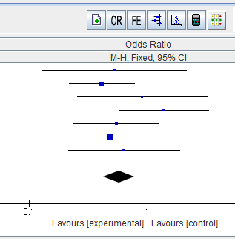

1. With the icons above the forest plot you can change the settings.   
   Play around with these settings and create exactly the following forest plot ( in .png format):

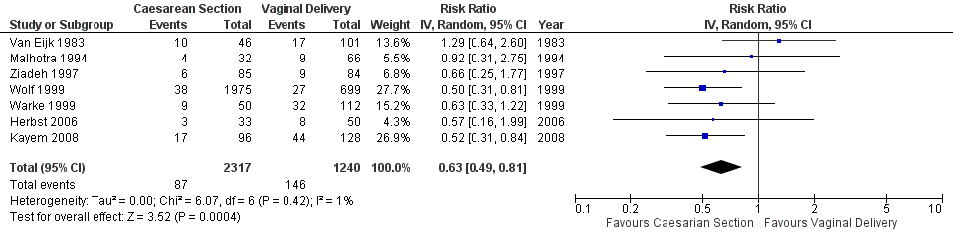

Use the “properties” button to create this forest plot, order studies by year, RR, RE, IV, axis scale 10, adapt labels.

**Meta-analysis with the software package R**

1. First, Open RStudio.

